**Bank Marketing Campaign Classifier Comparison**

This notebook analyzes and compares the performance of four classification algorithms: K-Nearest Neighbors (KNN), Logistic Regression, Decision Trees, and Support Vector Machines (SVM) on a dataset related to the marketing of bank products through telephone calls.

**Dataset Description and Loading**

The dataset contains information about a marketing campaign conducted by a Portuguese bank. It includes various features related to customer demographics, previous contact history, and the outcome of the campaign (whether the client subscribed to a term deposit). https://archive.ics.uci.edu/dataset/222/bank+marketing

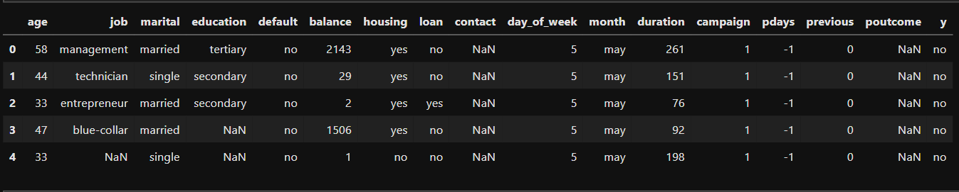

**Visualize model performance**

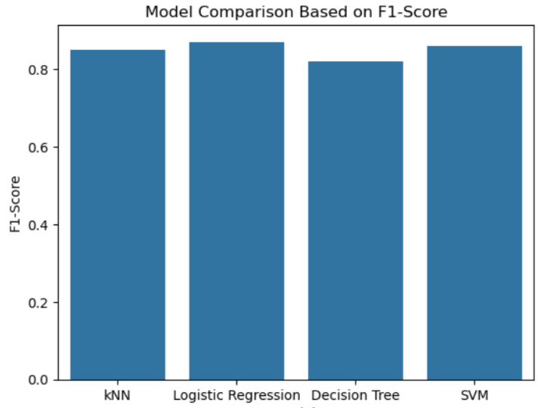

**Based on the analysis, the following insights were observed:**

* **KNN** demonstrated good performance but may struggle with larger datasets.
* **Logistic Regression** provided a straightforward interpretation of coefficients and performed well with linear relationships.
* **Decision Trees** excelled at capturing complex relationships but were prone to overfitting.
* **SVM** performed well in high-dimensional spaces but can be computationally expensive.

**Recommendations**

1. For better interpretability, Logistic Regression may be preferred.
2. For more complex decision boundaries, consider using Decision Trees or SVM.

**Conclusion**

This analysis compared various classifiers' performance in predicting customer subscriptions to bank term deposits. Each model's strengths and weaknesses were highlighted, providing valuable insights into which algorithms may be best suited for future marketing strategies. Overall, the choice of model should be guided by the specific context of the application, data characteristics, and the importance of interpretability versus prediction accuracy. Future work could involve hyperparameter tuning and exploring ensemble methods to further improve model performance.